CS 320 Software Testing, Automation, Quality Assurance
Module 7: Project 2
Summary and Reflections Report
Sean Fitzpatrick
8/14/2025

Summary:
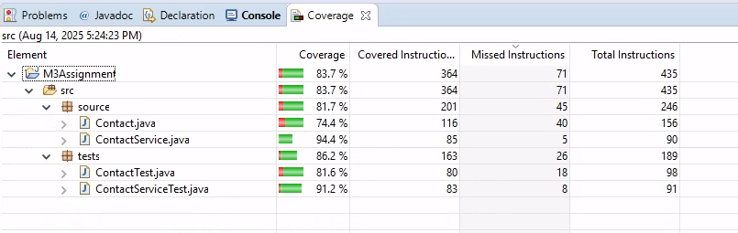
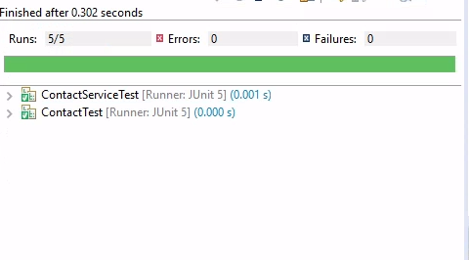
I approached this project very differently in the beginning than I did in the other sections. When I started, I focused on the requirements for each class, making sure that they were present in the code and that they met the specific requirements of the client. I made functional classes that, when tested for the desired inputs, worked perfectly. Test coverage was not on my mind during this phase of the project. The screenshots here show that while the test cases for ContactService.java and Contact.java were successful and efficient, the coverage was not complete. Having an overall coverage of almost 84% isn’t bad, but that means there is still a significant amount of coding that is not being touched by the test cases. During the final phase of the project, I went back and focused on coverage since I knew that the code itself was functional and met the specified requirements.

In the second phase of the project, I began to focus more on coverage. Once the basic coding was in place and met the requirements, I began to focus my test cases on more than just what was expected. I tried to come up with different examples of what should not be acceptable by the program. For example, having a field for a Task Name that was not null or exceeded a total of 20 characters, I created a test case that specifically entered a null Task Name. This tested the code’s ability to detect the null entry and throw the specified error. I had a similar test that entered a value that was greater than 20 characters.
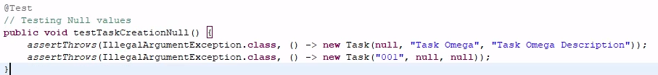
Figure 1Test case: Null entries for Task class
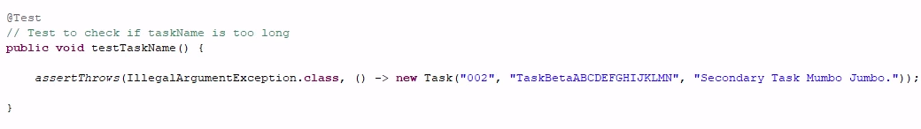
Figure 2Test case for Task name too long.
By the third phase of the project, I had refined my methods for testing the classes and achieving 100% coverage of the tested classes. I continued finding ways to test not only the expected inputs, but also the unexpected. With the experience of the earlier phases, I went back and looked over my test cases and came up with new, more interesting ways to test the code. The Task and Appointment classes were already at 100% coverage, but the Contact classes were not. By taking what I learned and thinking outside of the box, I was able to raise the coverage for those classes as well, bringing my overall coverage total to 84.2%.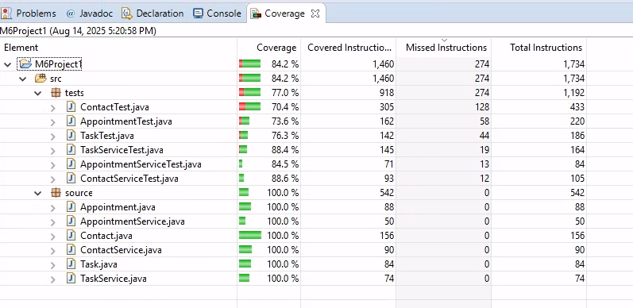
Figure 3Final Coverage.
Ensuring that the code was technically sound meant making sure that it could be easily maintained, was easy to follow and was efficient. Utilizing descriptive commenting throughout the code helps with not only keeping the code easy to read and follow but also maintaining. If somewhere in the future the requirements change to allow longer descriptions for tasks, then all the development team would need to do is open Task.java, go to the Public section of the class code and adjust the if-statement for the task description. 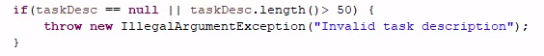
They can easily change or add the requirements in the statement. Then move on to the TaskTest.java class and search the comments for a test involving the description. They can then add a new test case or adjust an existing one to meet the new requirement. This is an example of easy maintenance.
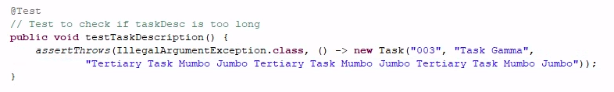
The above example of the test case for a description that is too long can be adjusted if the length of the description has been increased. All by adding to the previously existing test.
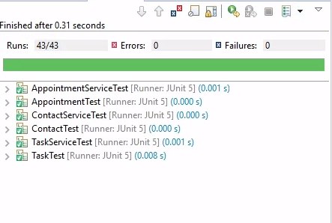
The overall test case efficiency can be seen in not just the coverage of the tests, but also the length of time taken to complete the tests. This screenshot of the final phase’s testing shows that when completed, there were 43 test runs, 0 errors, 0 failures and the entire testing process took less than 1 second to complete.
Reflection:
During this project, I focused on Unit testing most of all in my code design. I wanted to make sure that the class code itself was functional and met the set requirements given in the project. As I moved through the project, I began to focus on parameterized testing, working towards making sure that every line of code was covered by the test cases and evaluated as it should have.
I dd not use timeouts or nested testing at all during this project. Timeout tests involve creating tests that make sure the code is completed within a set time frame. I did not feel that this was necessary and would have just added extraneous code that could have negatively impacted the efficiency of the program. Nested testing was also not required for this project since it is used primarily in programs that have more complex tests. My test cases did not meet the need for nesting and trying to include it would have created more problems than it would have solved.
Initially my mindset on this project was one of a programmer fulfilling the request of a client. I focused on making sure that the client would have a product that did what they wanted it to do, prioritizing functionality over anything else. As I moved on in the project, I began to shift my testing mindset to that of someone who was hired to try and break the code. Someone who would intentionally try to make the system crash and fail. This type of approach allowed me to come up with tests that focused on accidental input, such as making an appointment for a date that was in the past, or accidentally hitting enter before entering a name, thus creating a null entry.
When writing the test case code, I approached it as an outsider hired to test the program. For example, I created test cases for types of input that I would try if I wanted to see if the actual program’s error catching code was functioning. Would the exception throw if a phone number that consisted of both numbers and characters be accepted? Depending on how a user is typing in their phone number, they might run the risk of hitting another key on the keyboard. The code would need to test for this and make sure that, if detected, it handles it properly.
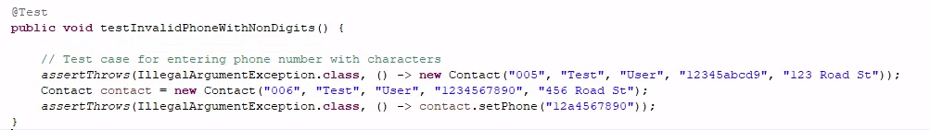
Having a commitment to quality is of great importance as a software developer. Creating code that is consistently high quality will help you gain a reputation that makes you desirable to companies as well as potential clients. The job market can be fierce and if you are too relaxed in your development, you could be passed over for a position that you would be overly qualified for or miss out on a massive development project for a system that could revolutionize an industry. Maintaining discipline in your coding is not just good for your software development in general, but also for your career aspirations.

